

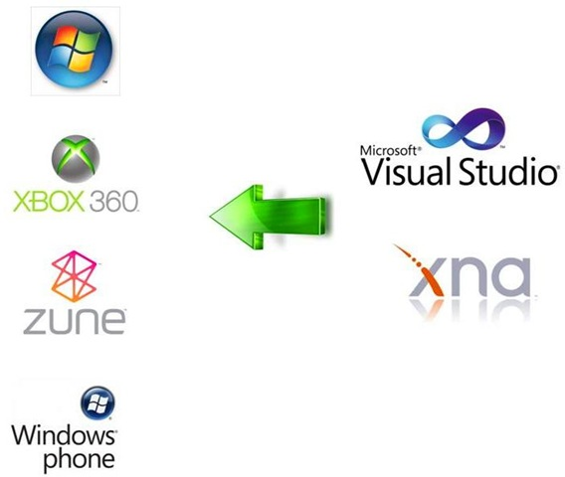

What’s New in XNA
Revised Project Folder Structure
Develop Games for Windows Phone Series
Graphics Profiles
Configurable Effects
Built-in State Objects
Scalars and Orientation
Revised Input API
Additional Audio API
Music and Picture Enumeration and Video Playback
Modified and Added Classes and Methods

Getting Started
System Requirements
Additional Resources
Installation
Creating Your First XNA Application
What You Just Did

Fun with Sprites
A Look Behind the Scenes
Game Development Versus Polling
Modifying Your Game
Adding a Sprite to Your Project
Loading and Drawing Your Sprite
Transparency and Other Options
Layer Depth
Let’s Move
Animation
Adjusting the Framerate
Adjusting the Animation Speed
What You Just Did

User Input and Collision Detection
More Sprites
Keyboard Input
Mouse Input
Gamepad Input
Keeping the Sprite in the Game Window
Collision Detection
What You Just Did

Applying Some Object-Oriented Design
Designing Your Classes
Creating a Sprite Class
Creating a User-Controlled Sprite Class
Creating an Automated Sprite Class
Game Components
Coding the SpriteManager
Cleaning Up
Making Them Move
What You Just Did

Sound Effects and Audio
Using XACT
Implementing XACT Audio Files in Code
Using the Simplified API for Sound and Audio
Adding More Sound to Your Game
What You Just Did

Basic Artificial Intelligence
The Turing Test
Creating Sprites at Random Intervals
Randomly Spawning Sprites
Irrelevant Objects
Creating a Chasing Sprite
Creating an Evading Sprite
What You Just Did

Putting It All Together
Drawing D Text
Randomly Generating Different Sprite Types
Adding Some Variety to Your Sprites
Adding a Background Image
Game Scoring
Game States
Enabling/Disabling GameComponents
Game-Over Logic and the Game-Over Screen
Fine-Tuning Gameplay
Creating Power-Ups
What You Just Did

D Game Development
Coordinate Systems
Cameras
Creating a D Camera
Drawing Primitives
Matrix Multiplication
Movement and Rotation
Backface Culling
More on Rotations
Even More Rotations
Primitive Types
Applying Textures
Table of Contents | ix
What You Just Did

D Models
Using D Models
Setting Up the Project
Adding a Model to Your Project
Drawing a Model Using a BasicModel Class
Adding a Model Manager
Rotating Your Model
What You Just Did

Creating a First-Person Camera
Components of a Moving D Camera
Moving in a First-Person Camera
Rotations in a First-Person Camera
Rotating a Camera in a Yaw
Rotating a Camera in a Roll
Rotating a Camera in a Pitch
Coding the Camera for the D Game
What You Just Did

D Collision Detection and Shooting
Creating a Moving Enemy
Adding Some Game Logic
Firing Shots
D Collision Detection and Bounding Spheres
Adding a Crosshair
Adding Sound
What You Just Did

HLSL Basics
HLSL Syntax
Dissecting a Sample HLSL Effect File
Applying an HLSL Effect in C#
Applying HLSL Using Textures
HLSL Effects: Creating a Negative
HLSL Effects: Blur
HLSL Effects: Grayscale
What You Just Did

Particle Systems
Creating a Particle Engine
Adding a Particle Effect File
Adding Your Particle Engine to Your Game
Adding a Starfield
What You Just Did

Wrapping Up Your D Game
Adding a Splash Screen Game Component
Keeping Score
Adding a Power-Up
What You Just Did

Deploying to the Xbox
Adding an Xbox Device
Converting a Project to Run on the Xbox
Supporting Gamepad Input
Deploying to the Xbox
Xbox Display Settings
The Title Safe Region
What You Just Did

Developing for Windows Phone
Setting Up Your Windows Phone Device
Registering for a Developer Account
Registering Your Windows Phone Device
Unlocking Your Phone
Creating a Windows Phone Project
Resources
Digging In
Screen Rotation and Resolution
More Model Classes
Adding a ModelManager
Finishing Details
What You Just Did

Multiplayer Games
Split-Screen Functionality
Network Game Development
Network Configurations
Writing an XNA Network Game
Modifying the Sprite Class
Modifying the UserControlledSprite Class
Coding Your Game Class
Adding Update Code
Updating While in the SignIn Game State
Updating While in the FindSession Game State
Updating While in the CreateSession GameState
Updating While in the Start Game State
Updating While in the InGame Game State
Updating While in the GameOver Game State
Adding Draw Code
Adding Biohazard Bombs of Insanity!
What You Just Did

